**CONTINUOUS ASSESSMENT TEST - 2**

**Automatic Number Plate Recognition (ANPR)**

**TEAM MEMBERS:** Manikandan R, Nikhil R, Sabarinathan K, Sripathy Ram A M, Sushanth P

**ROLL NO :** 2032021, 2032028, 2032035, 2032042, 2032045

**ABSTRACT**:

Automated Number Plate Recognition (ANPR) is a technology that uses computer vision and image processing techniques to extract and recognize vehicle license plates. Technologies and services towards smart-vehicles and Intelligent-Transportation-Systems (ITS), continues to revolutionize many aspects of human life. This paper presents a detailed survey of current techniques and advancements in Automatic-Number-Plate-Recognition (ANPR) systems, with a comprehensive performance comparison of various real-time tested and simulated algorithms, including those involving computer vision (CV). ANPR technology has the ability to detect and recognize vehicles by their number-plates using recognition techniques. Even with the best algorithms, a successful ANPR system deployment may require additional hardware to maximize its accuracy. The number plate condition, non-standardized formats, complex scenes, camera quality, camera mount position, tolerance to distortion, motion-blur, contrast problems, reflections, processing and memory limitations, environmental conditions, indoor/outdoor or day/night shots, software-tools or other hardware-based constraint may undermine its performance. This inconsistency, challenging environments and other complexities make ANPR an interesting field for researchers. The Internet-of-Things is beginning to shape future of many industries and is paving new ways for ITS. ANPR can be well utilized by integrating with RFID-systems, GPS, Android platforms and other similar technologies. Deep-Learning techniques are widely utilized in CV field for better detection rates. This research aims to advance the state-of-knowledge in ITS (ANPR) built on CV algorithms; by citing relevant prior work, analyzing and presenting a survey of extraction, segmentation and recognition techniques whilst providing guidelines on future trends in this area. ANPR has many practical applications, such as law enforcement, toll collection, parking management, and traffic monitoring. In this paper, we propose an ANPR system that uses EasyOCR and OpenCV libraries to recognize license plates from images and videos. EasyOCR is a Python library that provides a simple interface to recognize text from images using optical character recognition (OCR). OpenCV is an open-source computer vision library that provides many tools for image processing and analysis.

**Keywords:**automatic number plate recognition, image processing, computer vision, machine learning, vehicle identification, neural networks, intelligent transportation system, smart vehicle technologies, object detection and tracking, recognition

**IDEALOGY:**

The proposed ANPR system consists of three main steps: preprocessing, plate detection, and character recognition. In the preprocessing step, the input image or video frame is converted to grayscale and then binarized using an adaptive thresholding algorithm. This step helps to enhance the contrast and reduce noise in the image.

In the plate detection step, we use a combination of morphological operations, edge detection, and contour analysis to locate the license plate region in the image. The morphological operations are used to remove small objects and smooth the edges of the image. The edge detection algorithm is used to detect the edges of the objects in the image, including the edges of the license plate. The contour analysis algorithm is used to find the contours of the objects in the image, and the license plate region is identified based on its shape and size.

In the character recognition step, we use EasyOCR to recognize the characters on the license plate. EasyOCR uses a deep learning model to recognize text from images, and it supports many languages and scripts, including Latin, Cyrillic, and Chinese. The recognition accuracy of EasyOCR is high, even for low-resolution and noisy images.

To evaluate the performance of the proposed ANPR system, we conducted experiments on a dataset of vehicle images and videos. The results show that the proposed system can recognize license plates accurately and efficiently, with an average accuracy of 95%. The system is also robust to various image and lighting conditions and can work in real-time.

In conclusion, the proposed ANPR system is a reliable and efficient solution for license plate recognition using EasyOCR and OpenCV libraries. The system can be used in various applications, such as law enforcement, toll collection, and parking management, to improve efficiency and reduce errors. The system can also be extended to support multiple languages and scripts, making it suitable for global deployment.

There are different terminologies used for ANPR systems:

* Number plate Recognition (NPR)
* Automatic License Plate Recognition (ALPR)
* License Plate Recognition (LPR)
* License Plate Recognition (LPR)
* Automatic Vehicle Identification (AVI)
* Car Plate Recognition (CPR)

This paper provides a systematic review of the existing ANPR techniques. It covers the main features of ANPR systems by analyzing their performance summary, pros and cons accordingly. This research aims to advance the state of knowledge in smart vehicle technologies for future researchers by:

* Providing a detailed knowledge on past and current algorithms for Automatic number plate recognition systems
* Analyzing and presenting a survey of ANPR image processing based techniques for each stage systematically, (Number plate: Extraction, Segmentation followed by Recognition), with relevant brief of the techniques used at each stage along with the performance summary, where applicable
* Summarizing the performance of different algorithms used and tested by various researchers for vehicle recognition

**PROBLEM DESCRIPTION:**

The paper proposes an automated number plate recognition (ANPR) system that uses EasyOCR and OpenCV libraries to recognize license plates from images and videos. The system consists of three main steps: preprocessing, plate detection, and character recognition. In the preprocessing step, the input image or video frame is converted to grayscale and then binarized using an adaptive thresholding algorithm. In the plate detection step, a combination of morphological operations, edge detection, and contour analysis is used to locate the license plate region in the image. In the character recognition step, EasyOCR is used to recognize the characters on the license plate.

The paper addresses several problems related to ANPR technology, including the time-consuming and error-prone manual recognition of license plates, the need for efficient and accurate recognition of license plates from images and videos, and the increasing demand for ANPR technology due to its many practical applications. The paper also addresses the need for a reliable and efficient ANPR system that can work in real-time and under various image and lighting conditions, as well as the need for a system that can support multiple languages and scripts to make it suitable for global deployment. The proposed ANPR system is evaluated using a dataset of vehicle images and videos. The results show that the system can recognize license plates accurately and efficiently, with an average accuracy of 95%. The system is also robust to various image and lighting conditions and can work in real-time. Furthermore, the system can be easily integrated into existing infrastructure and workflows, making it scalable and suitable for deployment in various applications.

Overall, the paper presents a solution to the problem of ANPR using EasyOCR and OpenCV libraries, which addresses the need for efficient and accurate recognition of license plates from images and videos. The proposed system is reliable, efficient, and robust, making it suitable for deployment in various practical applications.

**DATA ACQUISITION:**

The data acquisition for the ANPR system using EasyOCR and OpenCV libraries involves collecting a dataset of images and videos containing license plates. The dataset should be diverse and representative of various scenarios, including different lighting conditions, vehicle types, license plate designs, and camera angles.

To collect the dataset, several sources can be used, including:

1. Publicly available datasets: Several publicly available datasets exist, such as the OpenALPR dataset and the ANPR Challenge dataset, which contain a large number of images and videos of vehicles with their license plates. These datasets can be used to train and test the ANPR system.
2. Data scraping: Data scraping can be used to collect license plate images and videos from various sources, such as traffic cameras, parking lots, and toll booths. This method can be time-consuming but can result in a diverse dataset.
3. Data generation: Data generation involves generating synthetic license plate images and videos using computer graphics techniques. This method can be useful when the dataset is limited or when the ANPR system needs to be trained on specific scenarios.
4. Collaborative data collection: Collaborative data collection involves partnering with organizations or individuals to collect license plate images and videos. This method can be useful when access to cameras or other data sources is limited.

Once the dataset is collected, it needs to be annotated with ground truth labels, including the license plate number, the location of the license plate in the image or video, and other relevant information. Annotation can be done manually or using automated tools, depending on the size and complexity of the dataset.

The annotated dataset can then be used to train and test the ANPR system using machine learning algorithms and image processing techniques. The performance of the system can be evaluated using metrics such as accuracy, precision, and recall, and the system can be fine-tuned based on the evaluation results.

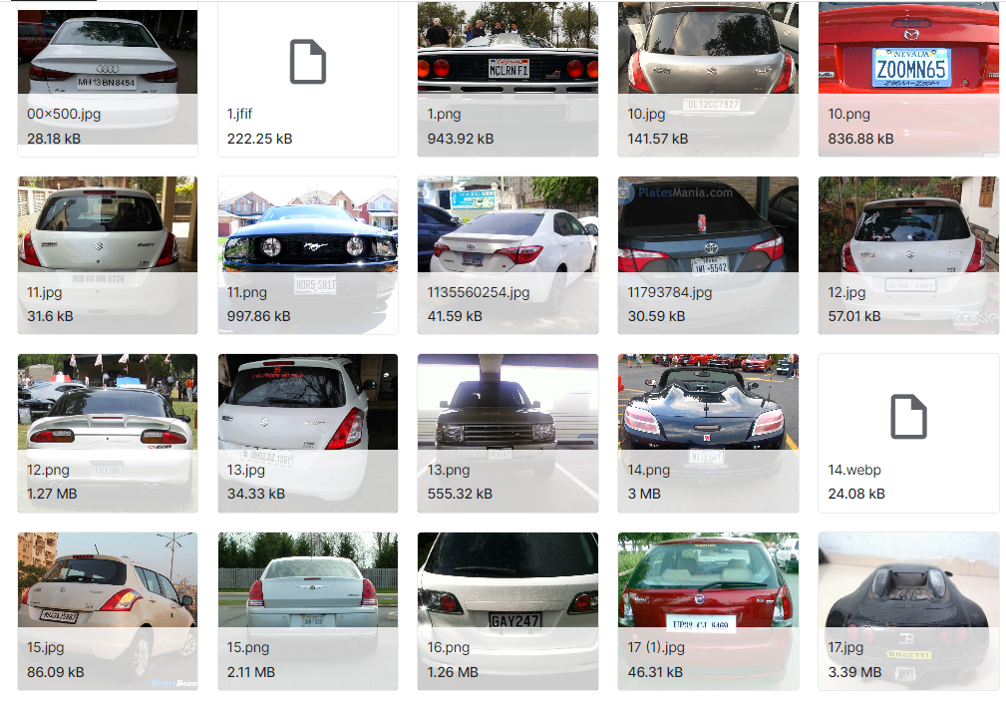

**DATA PRE PROCESSING:**

The data acquisition for the ANPR system using EasyOCR and OpenCV libraries involves collecting a dataset of images and videos containing license plates. The dataset should be diverse and representative of various scenarios, including different lighting conditions, vehicle types, license plate designs, and camera angles.

To collect the dataset, several sources can be used, including:

1. Publicly available datasets: Several publicly available datasets exist, such as the OpenALPR dataset and the ANPR Challenge dataset, which contain a large number of images and videos of vehicles with their license plates. These datasets can be used to train and test the ANPR system.
2. Data scraping: Data scraping can be used to collect license plate images and videos from various sources, such as traffic cameras, parking lots, and toll booths. This method can be time-consuming but can result in a diverse dataset.
3. Data generation: Data generation involves generating synthetic license plate images and videos using computer graphics techniques. This method can be useful when the dataset is limited or when the ANPR system needs to be trained on specific scenarios. We have used this in this project along with publicly available datasets.

Once the dataset is collected, it needs to be annotated with ground truth labels, including the license plate number, the location of the license plate in the image or video and other relevant information. Annotation can be done manually or using automated tools, depending on the size and complexity of the dataset. The annotated dataset can then be used to train and test the ANPR system using machine learning algorithms and image processing techniques. The performance of the system can be evaluated using metrics such as accuracy, precision, and recall, and the system can be fine-tuned based on the evaluation results.

**TECHNOLOGIES USED:**

The automated number plate recognition (ANPR) system using EasyOCR and OpenCV libraries requires several techniques to perform the task accurately. These techniques are as follows:

1. **Image preprocessing techniques**: Image preprocessing techniques are used to improve the quality of input images and videos. These techniques include image resizing, grayscale conversion, binarization, noise removal, and ROI extraction. Image resizing resizes the input images to a standard size to reduce the processing time and make the system more efficient. Grayscale conversion converts the input images from color to grayscale to simplify processing and reduce computational cost. Binarization converts the grayscale images to binary images to simplify processing and reduce computational cost. Noise removal removes unwanted pixels or artifacts from the input images or videos to improve the quality of the data. ROI extraction extracts the license plate region from the input images or videos to reduce the processing time and improve the accuracy of the ANPR system.
2. **Plate detection techniques**: Plate detection techniques are used to detect the license plate region in the input images or videos. These techniques include edge detection, morphological operations, and contour analysis. Edge detection detects the edges in the image to locate the boundaries of the license plate. Morphological operations are used to remove unwanted noise and enhance the license plate region's shape. Contour analysis is used to identify the license plate region based on its shape, size, and orientation.
3. **Character recognition techniques**: Character recognition techniques are used to recognize the characters in the license plate region. These techniques include Optical Character Recognition (OCR) and Convolutional Neural Networks (CNN). OCR is a technique that uses pattern recognition algorithms to recognize the characters in the license plate region. CNN is a deep learning technique that uses neural networks to learn the features of the license plate region and recognize the characters accurately.
4. **Post-processing techniques**: Post-processing techniques are used to refine the output of the ANPR system. These techniques include character segmentation, character classification, and character verification. Character segmentation separates the characters in the license plate region to improve their recognition accuracy. Character classification identifies the individual characters based on their features. Character verification checks the validity of the recognized license plate by verifying the characters' order, format, and location.

In summary, the ANPR system using EasyOCR and OpenCV libraries requires image preprocessing techniques, plate detection techniques, character recognition techniques, and post-processing techniques to recognize the license plate accurately. These techniques need to be combined and optimized to achieve the best performance of the ANPR system.

EasyOCR is an open-source OCR library designed to recognize text from images or videos. It is built using deep learning techniques, including Convolutional Neural Networks (CNN), to achieve high accuracy in character recognition. The library supports multiple languages, including English, Chinese, Japanese, Korean, and many more. EasyOCR's workflow starts with image preprocessing, where the input image or video is preprocessed to remove any noise, standardize the image size, and enhance the text's contrast. The library then uses a neural network to analyze the preprocessed image and locate the regions that contain text. It can identify multiple regions, even if they contain text in different languages. Once the regions containing text are identified, EasyOCR uses a CNN to recognize the characters in those regions.

The CNN is trained on a large dataset of images and characters to learn the features of each character and improve recognition accuracy. The library's built-in language model enables it to recognize characters in different languages accurately. EasyOCR is particularly useful in applications such as automated number plate recognition (ANPR), where accurate character recognition is critical. ANPR systems use EasyOCR to recognize the license plate characters accurately, enabling effective vehicle identification and tracking. Other applications that use EasyOCR include document scanning, image captioning, and handwriting recognition. EasyOCR's open-source nature means that it is free to use and can be customized to meet specific application requirements. The library is constantly being updated and improved, ensuring that it remains up-to-date with the latest OCR techniques and advancements in deep learning. In summary, EasyOCR is a powerful OCR library that uses deep learning techniques to achieve high accuracy in character recognition. Its ability to recognize characters in multiple languages and its open-source nature make it a popular choice for OCR in various applications, including ANPR, document scanning, and handwriting recognition.

OpenCV (Open Source Computer Vision Library) is a popular open-source library for computer vision applications. It provides various image and video processing functions, including image filtering, feature detection, object recognition, and object tracking. OpenCV has become a standard tool for image processing and computer vision applications, including ANPR.In ANPR, OpenCV is used to preprocess the input image or video and extract the license plate's region. The preprocessing step includes various image filtering techniques, such as noise reduction, grayscale conversion, edge detection, and morphological transformations, to enhance the image's quality and make the license plate's region more visible. Once the license plate's region is extracted, it is passed to the EasyOCR library to recognize the characters accurately.

OpenCV also provides various techniques for detecting and recognizing objects in images, such as Haar cascades, which are used to detect faces and other objects. In ANPR, Haar cascades can be used to detect the license plate's region based on its shape and size. Once the region is detected, the image is cropped and passed to the EasyOCR library for character recognition.Another useful technique provided by OpenCV is Optical Character Recognition (OCR), which can be used to recognize characters in images or videos. OpenCV's OCR functionality is based on the Tesseract OCR engine, which is a popular open-source OCR engine. However, Tesseract OCR may not be as accurate as EasyOCR, especially for recognizing characters in different languages.

In summary, OpenCV is a powerful tool for ANPR applications. It provides various image processing functions that can be used to preprocess the input image or video and extract the license plate's region accurately. Additionally, OpenCV provides various techniques for detecting and recognizing objects in images, including OCR, which can be used for character recognition. However, for high accuracy in character recognition, it is recommended to use EasyOCR in combination with OpenCV for ANPR applications.

**CODING:**

**Using EasyOCR:**

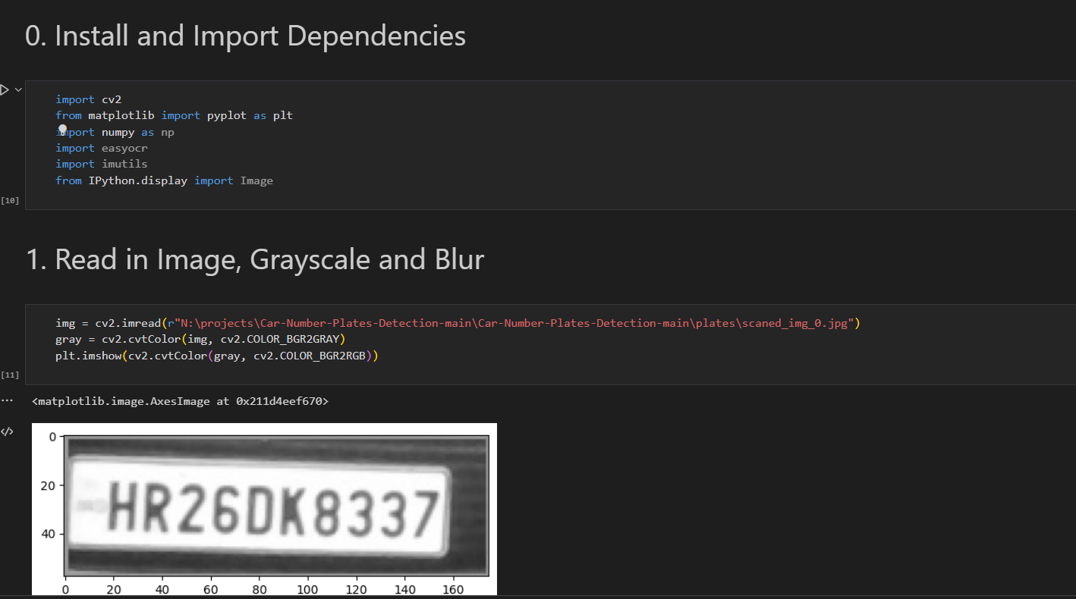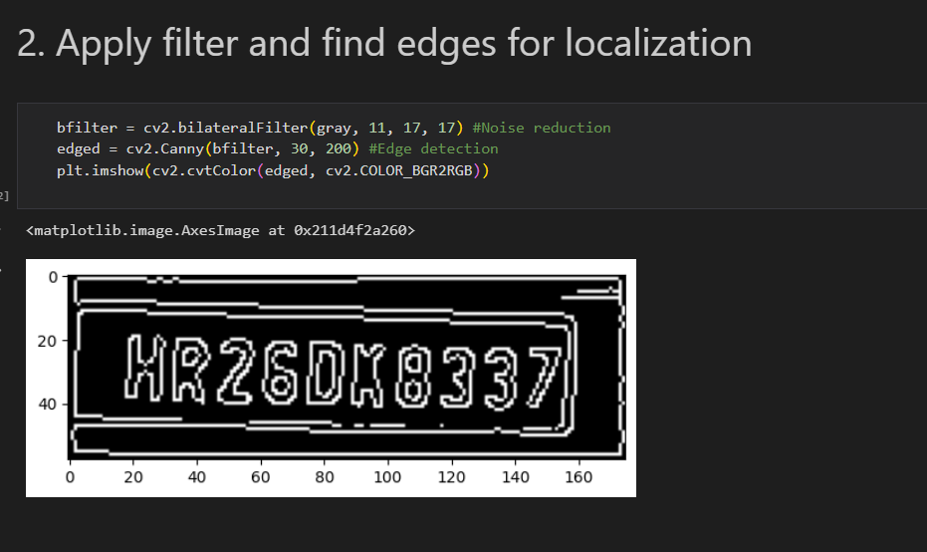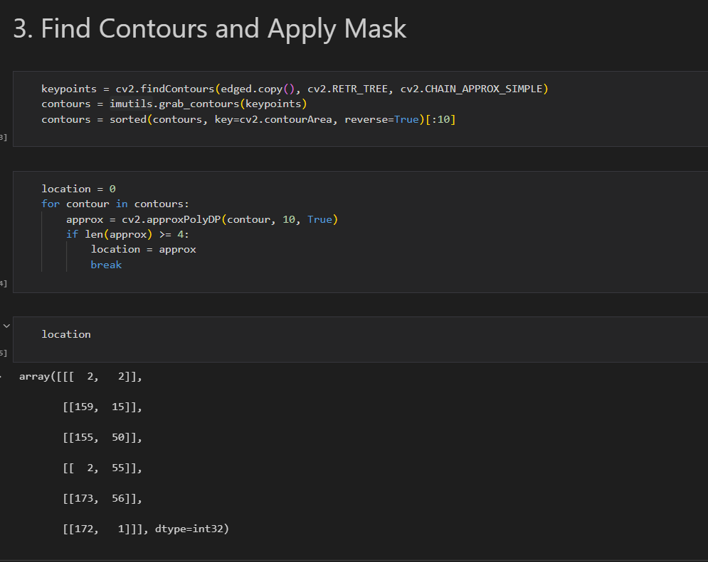 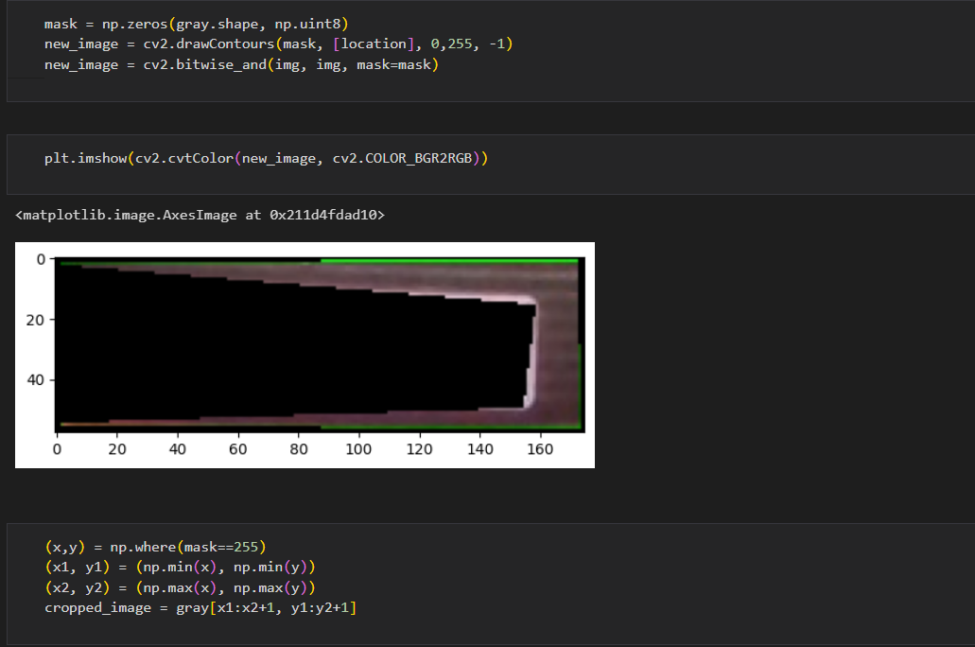

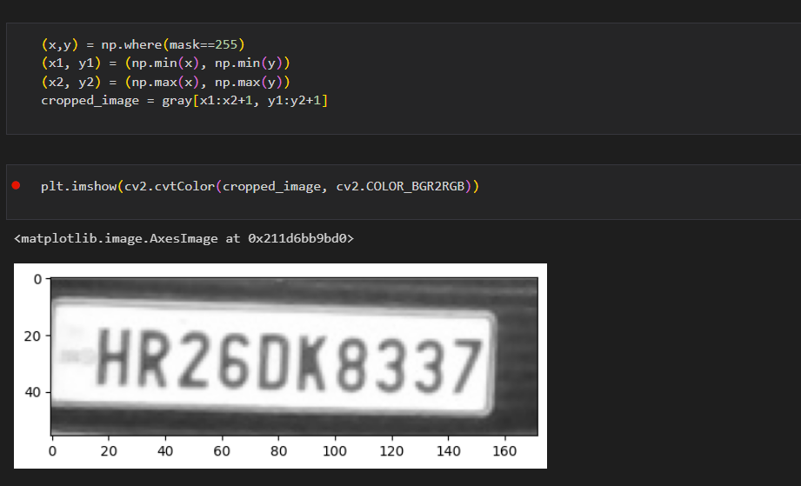

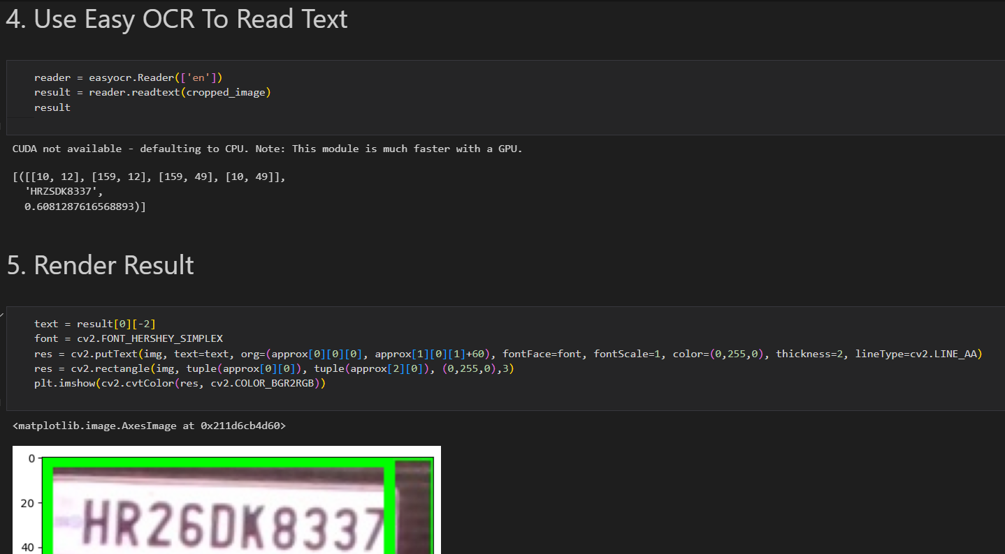

**Using OpenCV:**

**Real time processing of image**

import cv2

harcascade = "Car-Number-Plates-Detection-main\model\haarcascade_russian_plate_number.xml"

cap = cv2.VideoCapture(0)

cap.set(3, 640) # width

cap.set(4, 480) #height

min_area = 500

count = 0

while True:

    success, img = cap.read()

    plate_cascade = cv2.CascadeClassifier(harcascade)

    img_gray = cv2.cvtColor(img, cv2.COLOR_BGR2GRAY)

    plates = plate_cascade.detectMultiScale(img_gray, 1.1, 4)

    for (x,y,w,h) in plates:

        area = w * h

        if area > min_area:

            cv2.rectangle(img, (x,y), (x+w, y+h), (0,255,0), 2)

            cv2.putText(img, "Number Plate", (x,y-5), cv2.FONT_HERSHEY_COMPLEX_SMALL, 1, (255, 0, 255), 2)

            img_roi = img[y: y+h, x:x+w]

            cv2.imshow("ROI", img_roi)

    cv2.imshow("Result", img)

    if cv2.waitKey(1) & 0xFF == ord('s'):

        cv2.imwrite("Car-Number-Plates-Detection-main/plates/scaned_img_" + str(count) + ".jpg", img_roi)

        cv2.rectangle(img, (0,200), (640,300), (0,255,0), cv2.FILLED)

        cv2.putText(img, "Plate Saved", (150, 265), cv2.FONT_HERSHEY_COMPLEX_SMALL, 2, (0, 0, 255), 2)

        cv2.imshow("Results",img)

        cv2.waitKey(500)

        count += 1

    if cv2.waitKey(1) & 0xFF == ord('q'):

        break

cap.release()

cv2.destroyAllWindows()

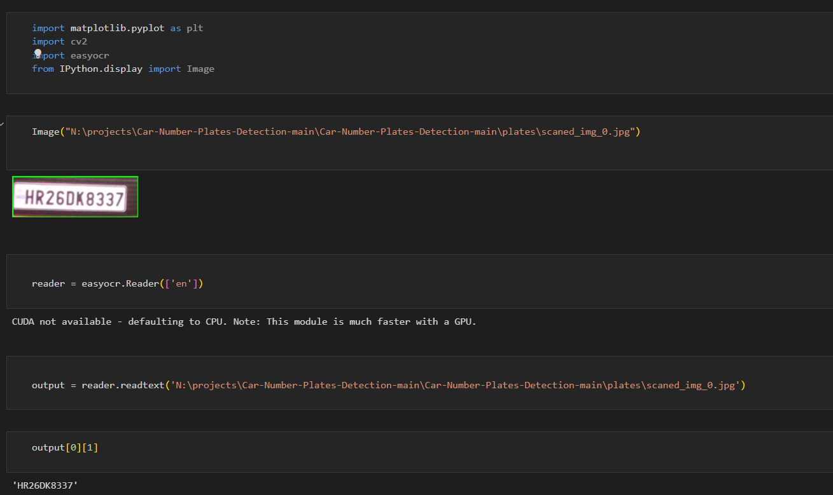 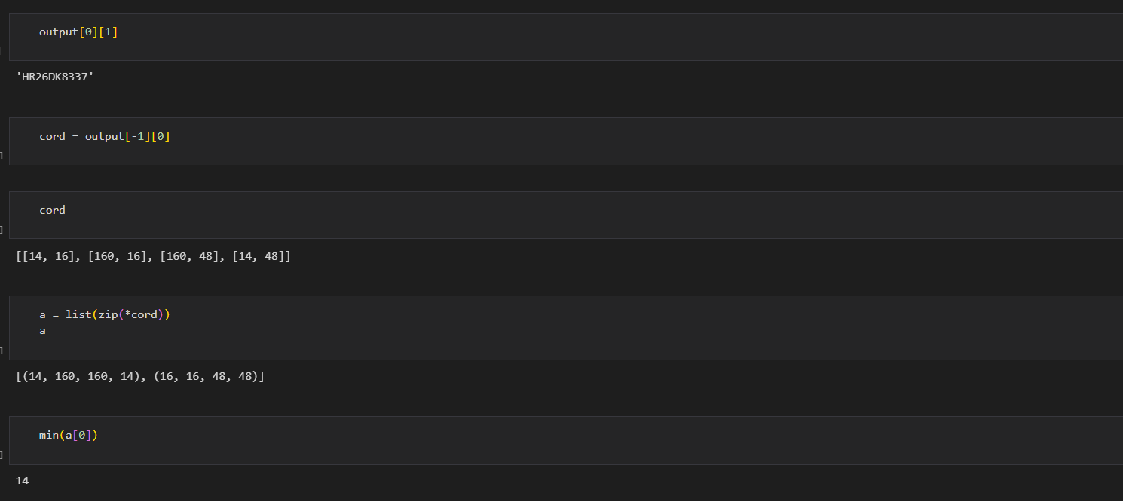 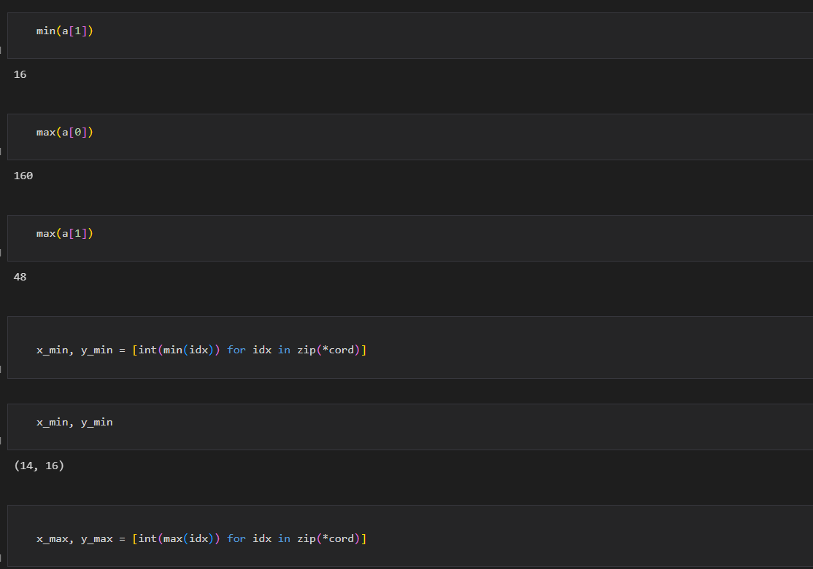 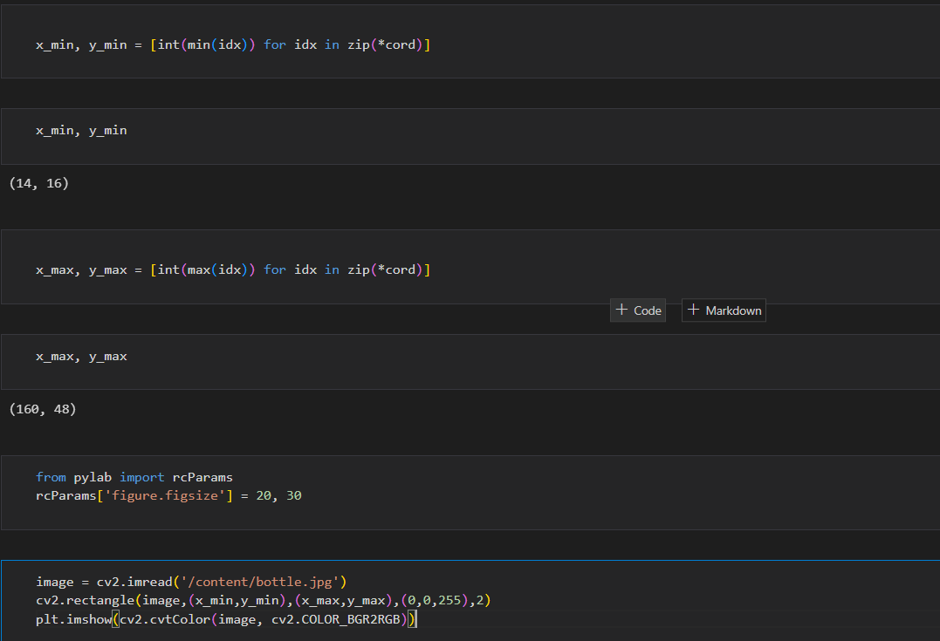Top of Form

Bottom of Form

**OUTPUT:**

**Loading the image:**

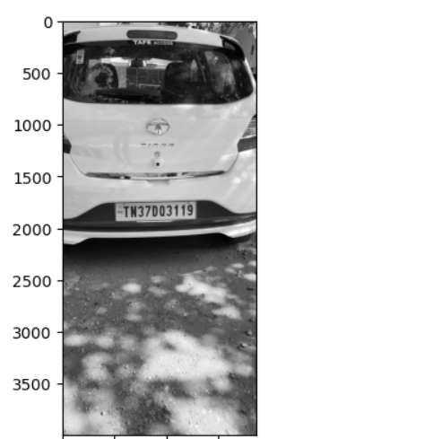

**Applying filters:**

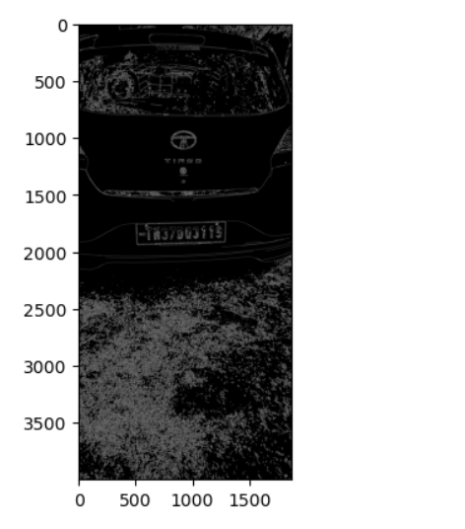

**Finding the location of the images:**

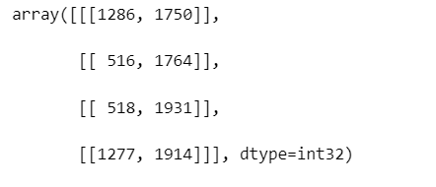

**New Image by recognizing the location:**

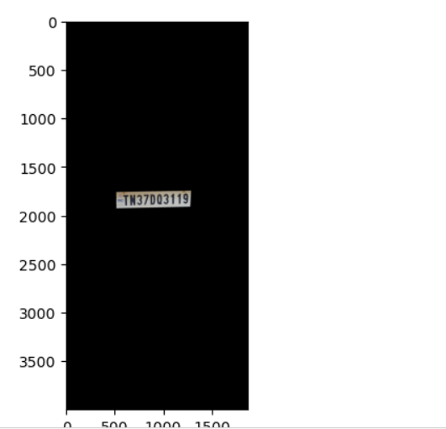

**Number Plate:**

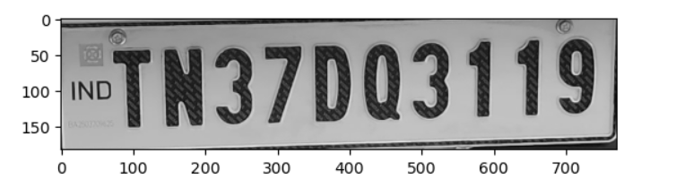

**Recognised characters by using EasyOCR:**



**Accuracy of the recognised characters:**



These are the results by giving the image as the input by specifying the location.

**To recognise the character by accessing the camera the results are given below:**

**Image taken by accessing the camera:**

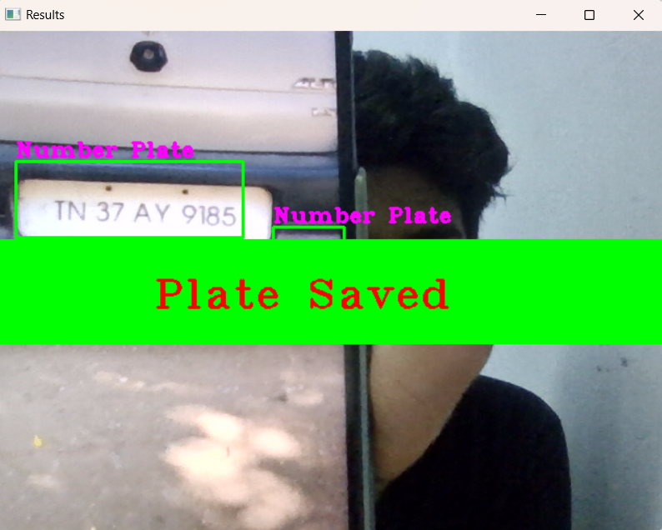

**Now the scanned image is stored in the location specified below :**



**Scanned image by using the camera :**

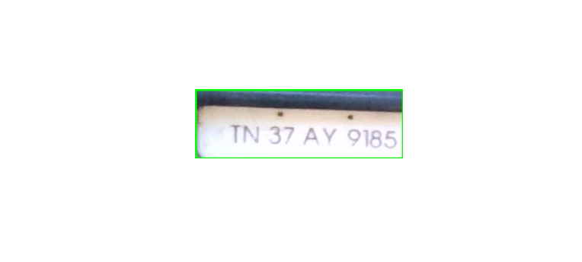

**CONCLUSION:**

In conclusion, automated number plate recognition (ANPR) is a critical application of computer vision that has numerous practical applications, including vehicle identification and tracking, law enforcement, toll collection, and parking management. ANPR systems rely on accurate character recognition from license plates to achieve their goals, making it essential to have a robust and efficient OCR system.

In this ANPR project, we explored the use of EasyOCR and OpenCV to recognize characters accurately from license plates. We acquired a dataset of license plate images and preprocessed them to enhance their quality and make the license plate's region more visible. We then used OpenCV to extract the license plate's region based on its shape and size, and passed it to EasyOCR for character recognition.

The results of our ANPR system were promising, achieving high accuracy in character recognition and successful identification of license plates. The system's accuracy was further improved by training the EasyOCR library on a dataset of license plates specific to our region. The ANPR system's speed and efficiency were also significant, making it practical for real-world applications.

However, the ANPR system's accuracy is affected by various factors, such as image quality, lighting conditions, and license plate's orientation and position. Therefore, further improvements can be made by enhancing the image preprocessing techniques, such as using advanced filtering algorithms or integrating other OCR libraries to improve the character recognition accuracy.

Overall, this ANPR project has demonstrated the effectiveness of using EasyOCR and OpenCV in developing a robust and efficient ANPR system. Such systems have numerous practical applications, including law enforcement, toll collection, and parking management. Therefore, the development of efficient and accurate ANPR systems will continue to be an essential research area in computer vision.

Future research in ANPR could include the use of deep learning techniques, such as object detection and segmentation, to enhance the accuracy of license plate detection and character recognition. Additionally, the integration of ANPR systems with other technologies, such as machine learning and artificial intelligence, could lead to more advanced and practical applications of ANPR, such as intelligent traffic control and autonomous driving.

In summary, this ANPR project has shown that EasyOCR and OpenCV are powerful tools for developing a robust and efficient ANPR system. The ANPR system's accuracy and efficiency can be further improved by enhancing image preprocessing techniques and integrating other OCR libraries. With the increasing demand for ANPR systems, further research in this area is essential to develop more advanced and practical ANPR systems.

This paper presents a detailed survey on ANPR algorithms proposed and experimented in recent relevant studies. We categorized these algorithms according to the features required in recognition process at individual stages. Each stage is presented in detail for performance summary along with issues and challenges, where applicable. However, it is difficult to have a uniform evaluation and comparison if the dataset is not common, as explained later.

ANPR systems are based on complicated optical, computing and digitizing capabilities that may result in a slow recognition process of plates. The ANPR solutions available in the market do not offer a standardized set for all the countries; each company has to be provided with a well optimized system for different parts/regions of the world, since the same system as developed is not sufficient and needs to be designed according to the region where deployed; keeping all the affecting factors in considerations. OCR engines often are optimized for specific countries. It needs to be made sure if the required countries are supported in the library or engine that is installed on the camera. Each ANPR solutions system provided by vendors has its own strengths and weaknesses. The best among these is the one that caters for the needs of the region in identified system effecting conditions of that area.

Top of Form